- Install HotPot on your system from here
- Create Hot Potatoes exercise on your PC using the following three steps
- Step 1: Entering data
In this part of the tutorial, we're going to make a multiple-choice exercise using JQuiz. The first stage is to enter the questions and answers for your exercise. First, start the JQuiz program. You should see an interface like the one below. If your interface looks more complicated than this, it's probably switched to advanced mode; in that case, just click on Options / Mode / Beginner Mode.
Look at the picture below, and type in the information:
- Type the title in the title box.
- Type the question in the question box.
- Make sure that "Multiple-choice" is selected in the drop-down list box to the right of the question. This defines the type of question you want to make.
- Type the answers in the boxes on the left, and the feedback on the right. Note that each answer, right or wrong, has its own feedback.
- Check the "Correct" checkbox next to answer B.
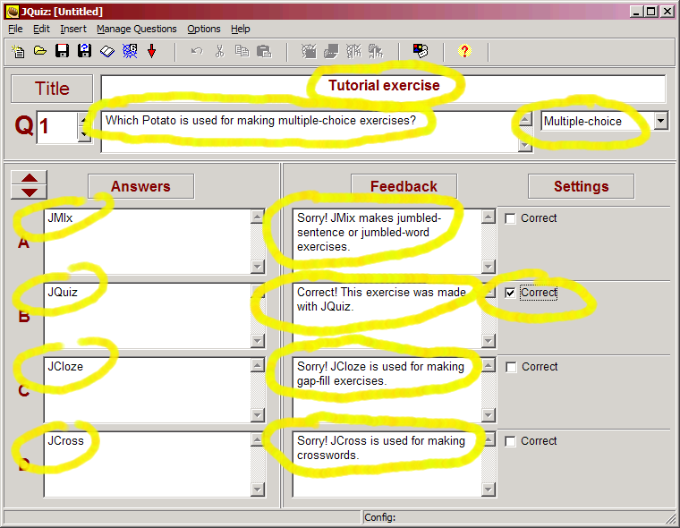
- Step 2: Configuring the output
When a Hot Potatoes program creates Web pages, it does so by combining 3 resources:
- The data you entered
- The configuration information
- A set of "source files", or templates, containing the page structure.

We have already looked at data; the next step is Configuration. The configuration information is a collection of pieces of text, including instructions for doing the exercise, button captions, and link URLs, which are unlikely to change much from one exercise to another. For example, some of the sample exercises you looked at earlier in this presentation included a button labelled "Check", so that the student could check his or her answer. The caption "Check" is not likely to change from exercise to exercise, so it does not need to be stored with the data; however, you may need to change it (if you are creating quizzes in another language, for example).
When you looked at the example multiple-choice exercise, you might remember that the exercise had a title, a subtitle, and some instructions at the top of the page. The title of each exercise is likely to be unique, so that's part of the data. However, the subtitle (e.g. "Multiple-choice exercise") and the instructions ("Choose the correct answer for each question") may be the same for most similar exercises, so these are part of the configuration. In Step 2, we're going to change the configuration.
First, click on Options / Configure Output to get to the configuration screen. The first tab, labelled Titles/Instructions, holds the exercise subtitle and instructions. Type some text in, as in the example below, then press OK.
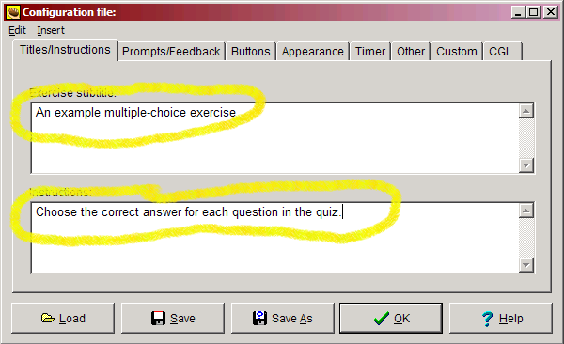

- Step3: Beginner and Advanced modes
On the Options menu, there is a Mode setting so you can choose between Beginner or Advanced interface features. These are the features which are hidden in Beginner mode:
Question Weighting
With this option, you can change the relative importance of different questions in the overall score. For instance, you could set one question to be worth only 10, while another is worth 100 (the range is 0-100); in this case, the score for the second question would be worth ten times as much as a component of the overall quiz score than the score for the first question.
Another use for question weighting might be to give students one or two "trial questions" at the beginning of a quiz, in case they're new to online exercises. If you set the question weighting to zero, then the student can do the question without penalty; there will be no effect on their score.
Percentage Correctness for Answers
Using this option, you can give answers a percentage value for correctness. Each question should of course have at least one answer which is 100% correct -- the preferred correct answer -- but other answers may be partially correct, and you might want your students to get some credit in the scoring for choosing or typing a partly-correct answer.
Accept As Correct setting
This option allows you to designate that an answer should be "accepted as correct" if the student chooses it, even if its percentage correctness is not 100%. This has the effect of "finishing" the question on the Web page, so that no further tries will be accepted. If you want your exercise to behave like a traditional test, where only one attempt is allowed, then you could set all your answers to "accept as correct".
2. Add HotPot activity to your LMS course by Logging in to LMS, and navigating to a course page
3. Enable "Edit mode" on course page
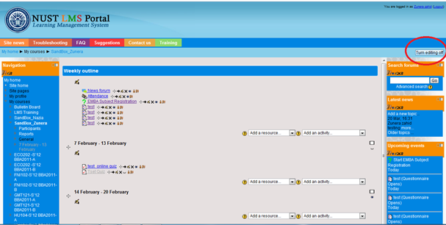
4. Locate course topic/week where you wish to add the Hot Potatoes exercise
5. Select "HotPot" from "Add an activity" menu
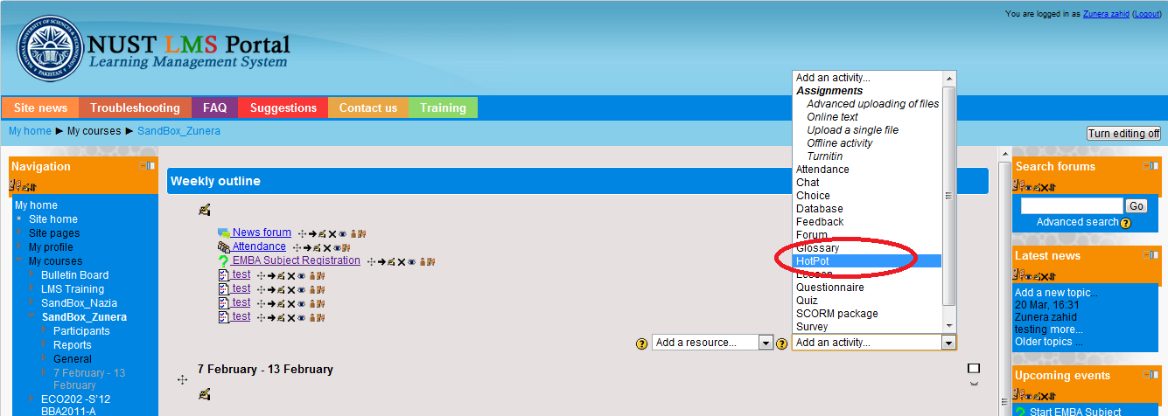
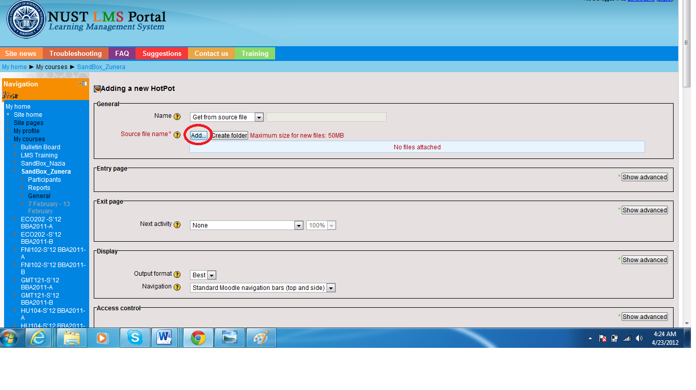
- Next to "Source file name" click "Add" button

- Click "Upload a file", then "Browse" to the Hot Potatoes file on your PC
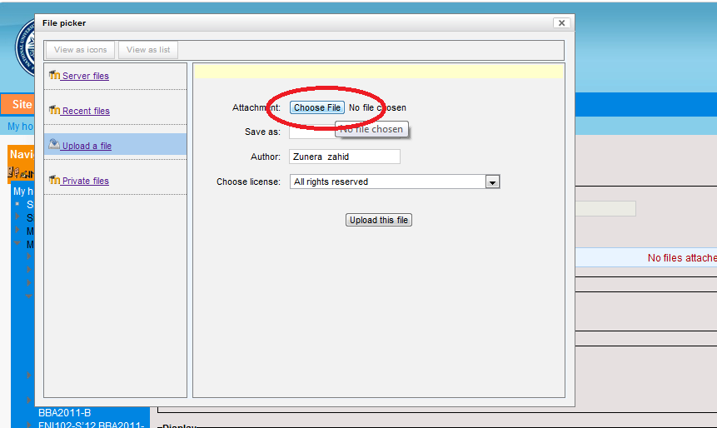

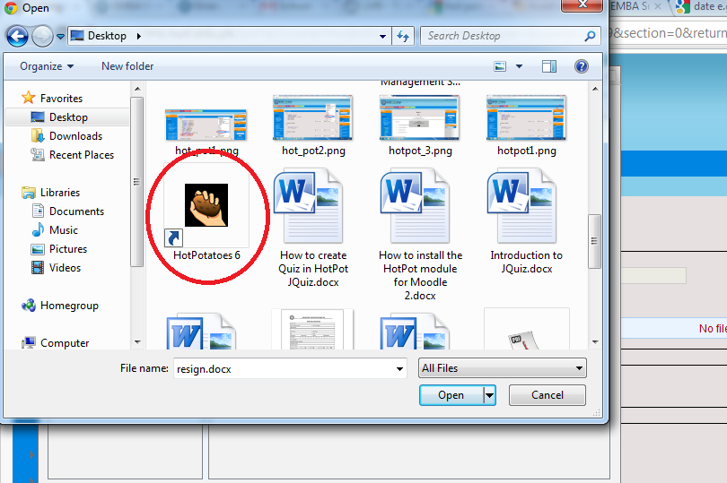
- Click "Upload this file"
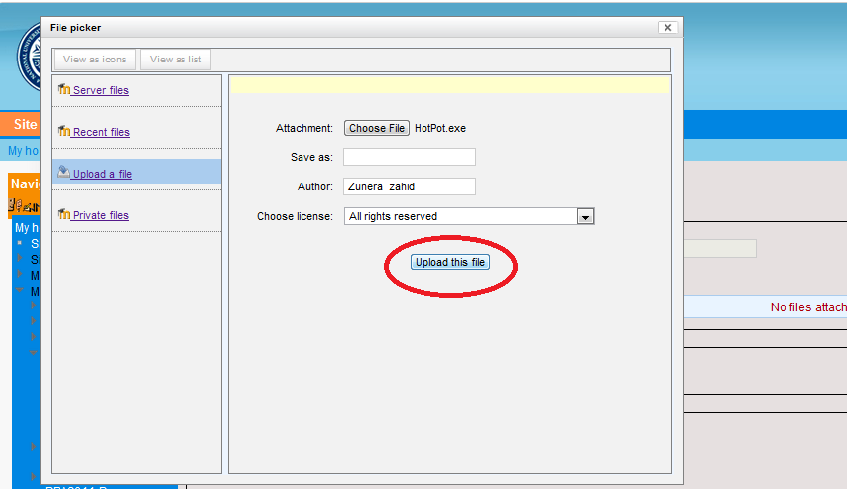
9. Review other settings
10. Click "Save changes" at bottom of page

