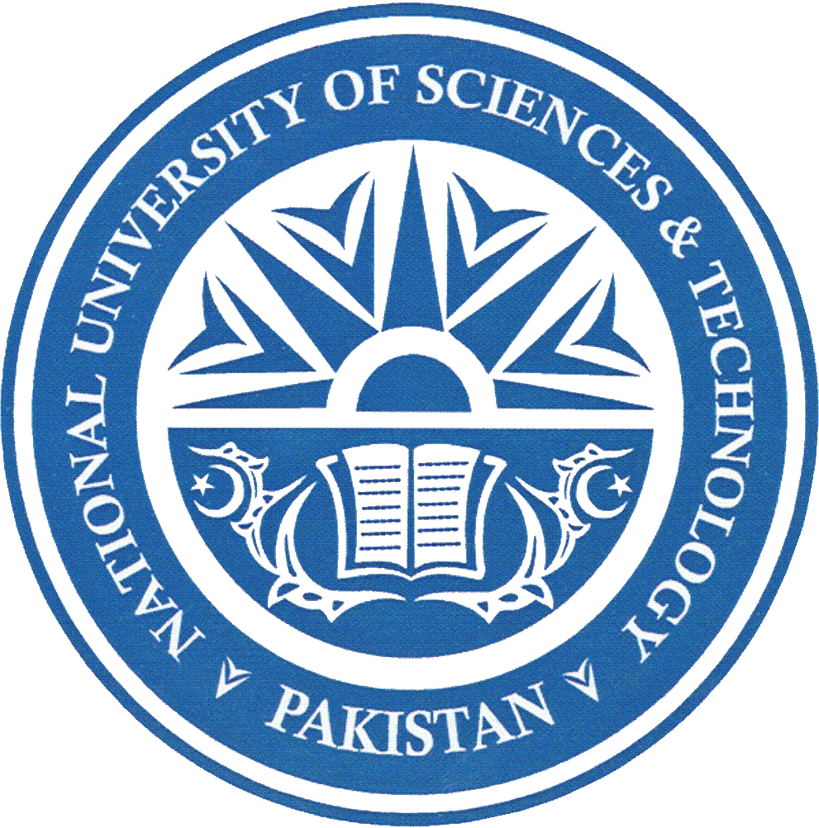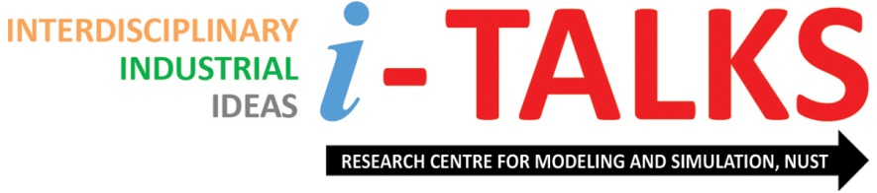

RESEARCH CENTRE FOR MODELING & SIMULATION
NATIONAL UNIVERSITY OF SCIENCES & TECHNOLOGY,
H-12 CAMPUS, ISLAMABAD

TITLE:
Technological Challenges in Designing Next Generation Fighter Aircraft (NGFA) – Project Azm

About the Speaker:

Dr. Messam Abbas Naqvi is working as Chief Project Director of Project Azm at newly established Aviation City, Kamra, Pakistan. He received his Bachelor’s in Aerospace Engineering from College of Aeronautical Engineering, PAF Academy, Risalpur in 1993. He is a sword of honour from Pakistan Air Force. He completed Masters in Aerospace Engineering from Georgia Institute of Technology, USA in 2002 and Masters in Industrial and Systems Engineering from the same institute in 2003. He went ahead and got his Doctoral degree in Aerospace Engineering (Aircraft Design) from Georgia Institute of Technology, USA in 2006. He is the only Pakistani to be the proud recipient of Robert G Shakelford Fellows Program and worked on the “Entomopter” the flapping wing bird for NASA rover’s last mission to Mars. His bibliography was included in the Worlds Who’s is Who in 2016 based on his research contributions. Currently, he is team lead for conceptual design of Next Generation Fighter Aircraft (NGFA) at AVRID, Kamra. He holds industrial experience of more than two decades and has thousands of students across Pakistan. His current research interests are Multi-disciplinary Design Optimization, Applied Aerodynamics and Aircraft Design.

About i-TALKS:

‘iOTA TALKS’ is the initiative of Research Centre for Modeling & Simulation to promote the culture of practical scholastic interactions at NUST. The talks cover all areas of science and engineering that foster interdisciplinary education and research, industrial initiatives or ideas that can shape our future; we call them iota to signify complexity. Through this platform, problem-centric solution approaches are discussed so that the gap between industry, academia and public-sector organizations can be bridged.

Date / Venue / Time:
Wednesday 24 January 2018 / ASAB Auditorium / 1100 hrs

